Project 2: Databricks Medallion Architecture
Task: Create an architecture of the project
Project overview:
This project implements an end-to-end modern data pipeline using Azure services to process large volumes of banking data. The architecture is built using Azure Data Lake Storage Gen2, Azure Databricks, and Power BI, and it follows the Medallion Architecture approach, which organizes data into Bronze, Silver, and Gold layers to improve data quality, scalability, and performance.

Tools to be used:
Data container, Cluster, Databrciks notebooks, Azure Data Lake Storage Gen2, Azure Databricks, and Power BI

Flow chart representation:
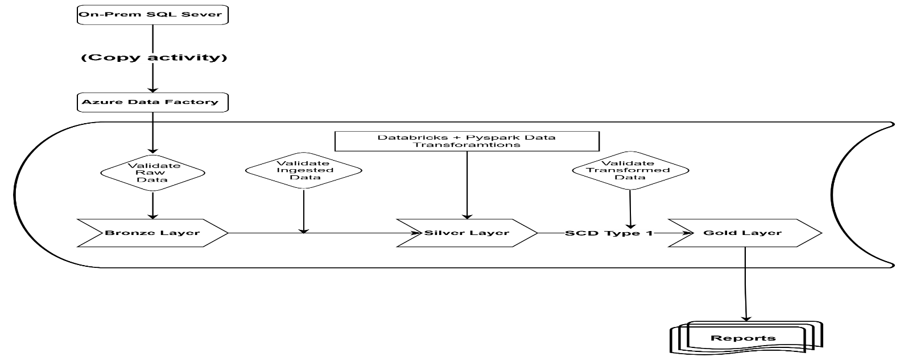

Architecture:
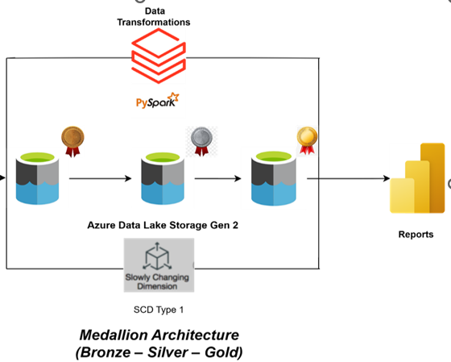

Overview of the Architecture:
The diagram represents an end-to-end Azure Data Engineering pipeline built using Medallion Architecture (Bronze, Silver, Gold). Data is initially stored in Azure Data Lake Storage Gen2 (ADLS Gen2). The raw data is first stored in the Bronze layer, which preserves the original data without any transformations. The data is then processed in Azure Databricks using Python, where various transformations such as null checks, date validations, duplicate removal, column renaming, and timestamp creation are performed to produce clean datasets stored in the Silver layer as Delta tables. Further business logic is applied in the Gold layer to update records by overwriting existing values with the latest data. Finally, the curated data from the Gold layer is connected to Power BI, which is used to generate dashboards and reports for business insights and decision-making. This architecture ensures scalable data processing, improved data quality, and efficient analytics.

Implementation Steps:
Step 1: Login to Azure Portal
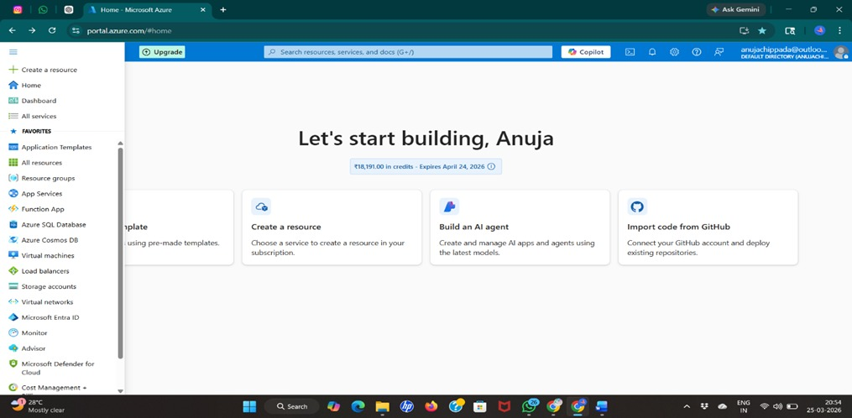
Step 2: Create Resource Group

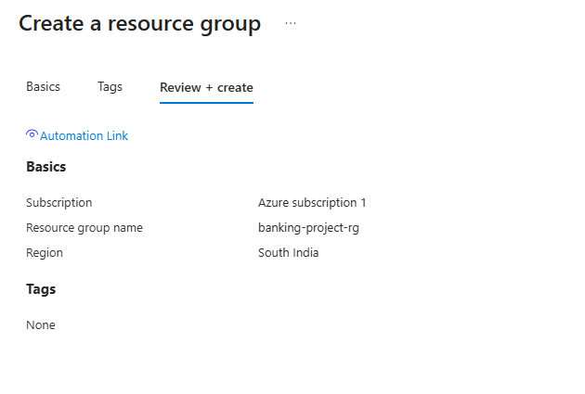

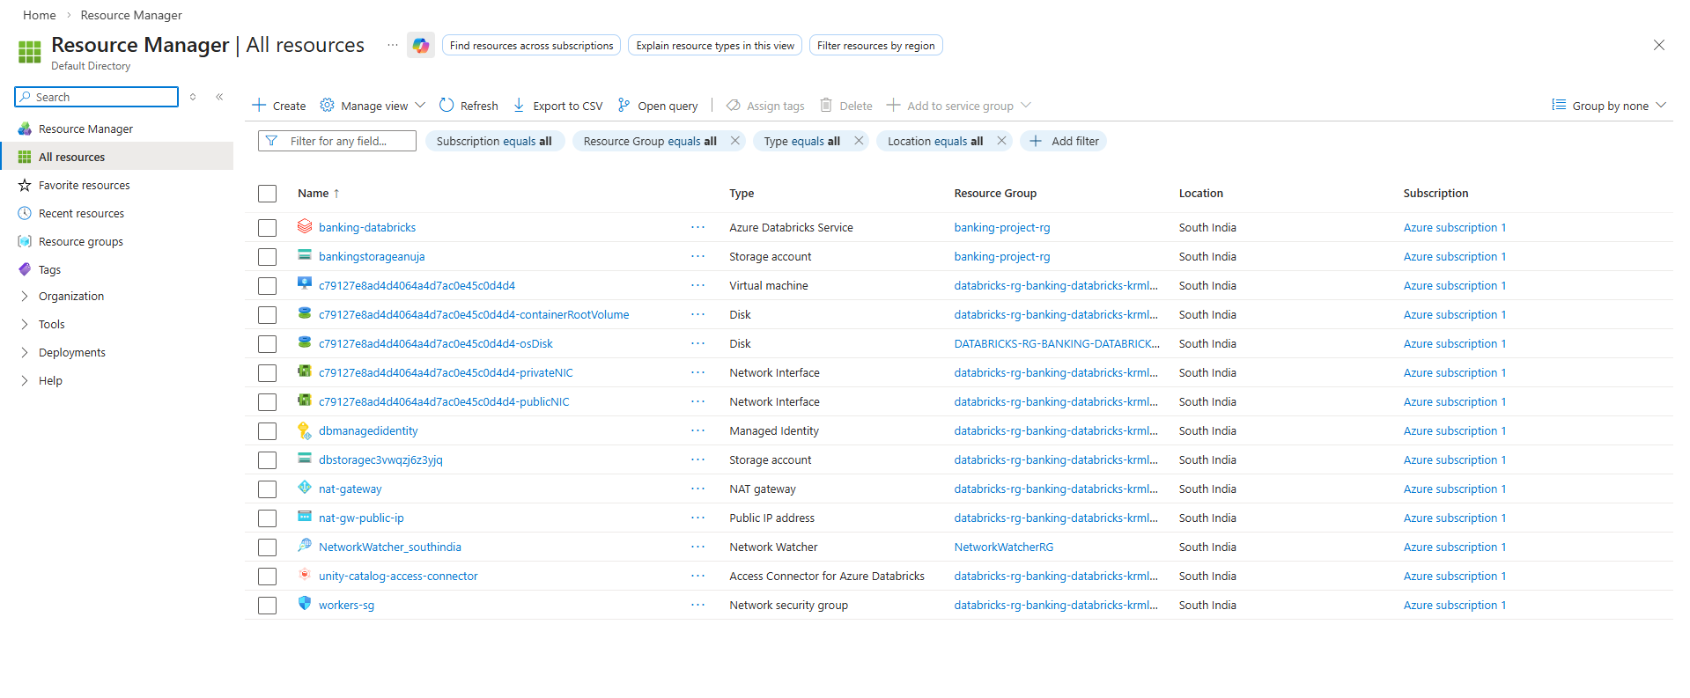
Step 3: Create Azure Data Lake Storage Gen2
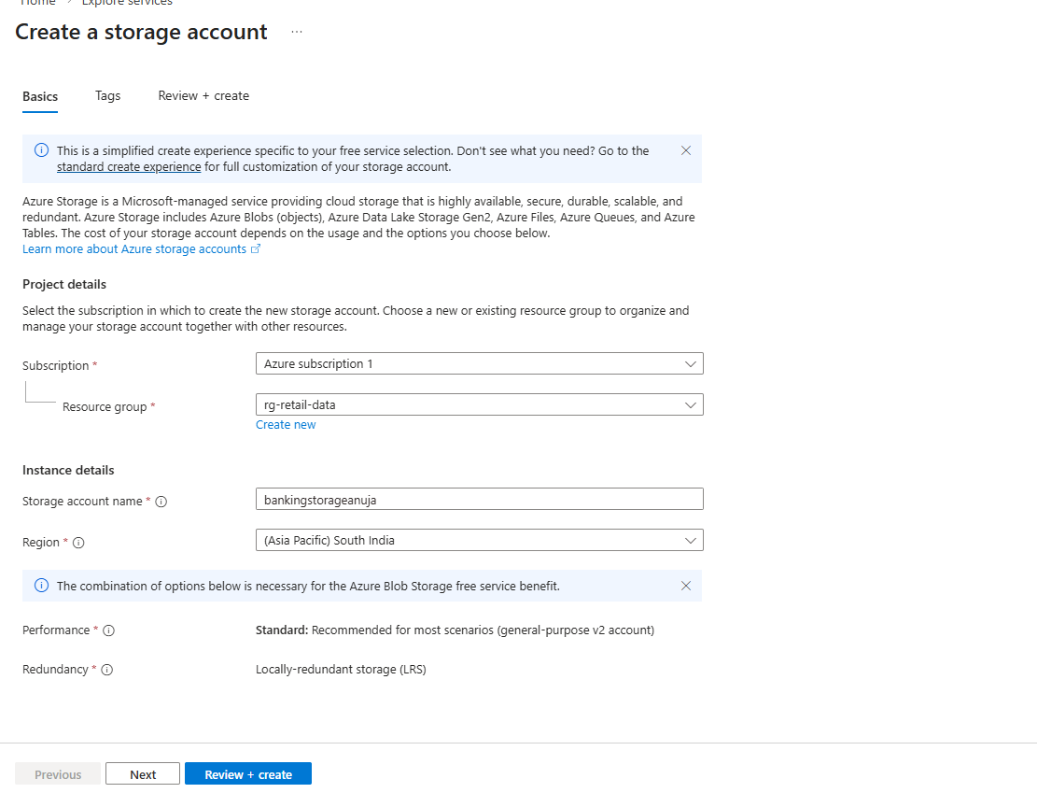
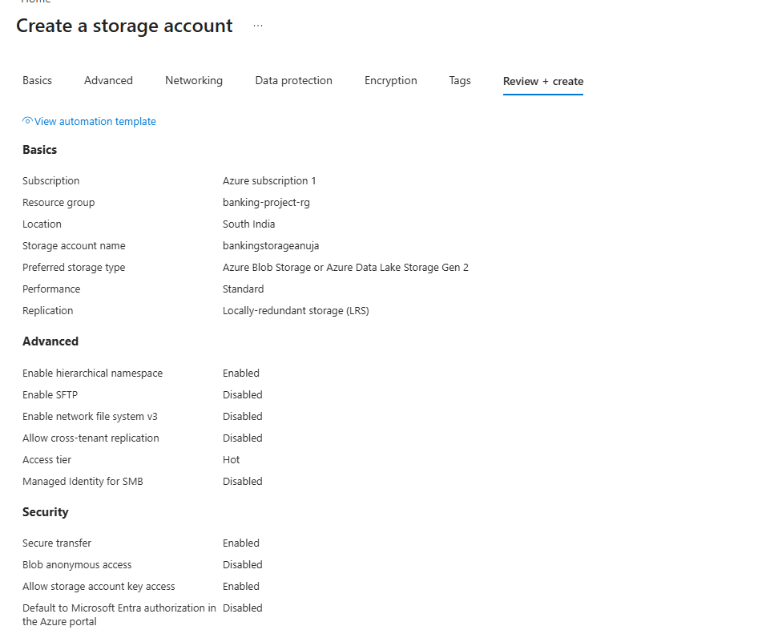

Step 4: Create Layers in ADLS:
- Bronze (Raw Data)
- Silver (Cleaned Data)
- Gold (Final Data)
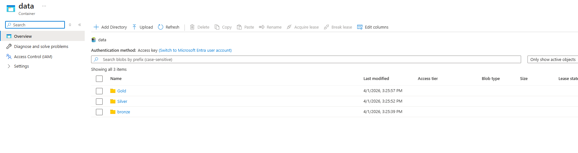
Step 5: Upload the Transaction_CSV file in bronze layer
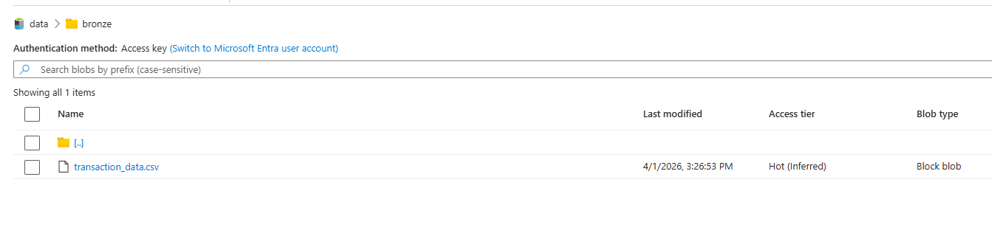
Step 6: Created Databricks Workspace
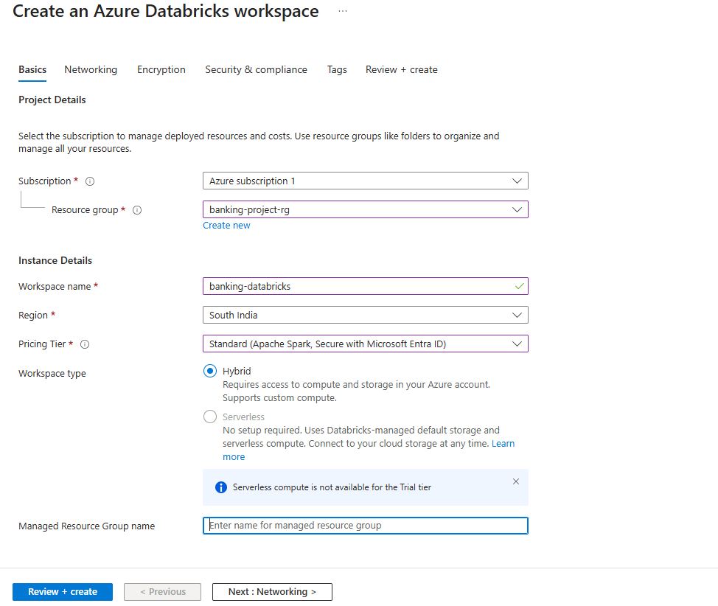

Step 7: Create Cluster
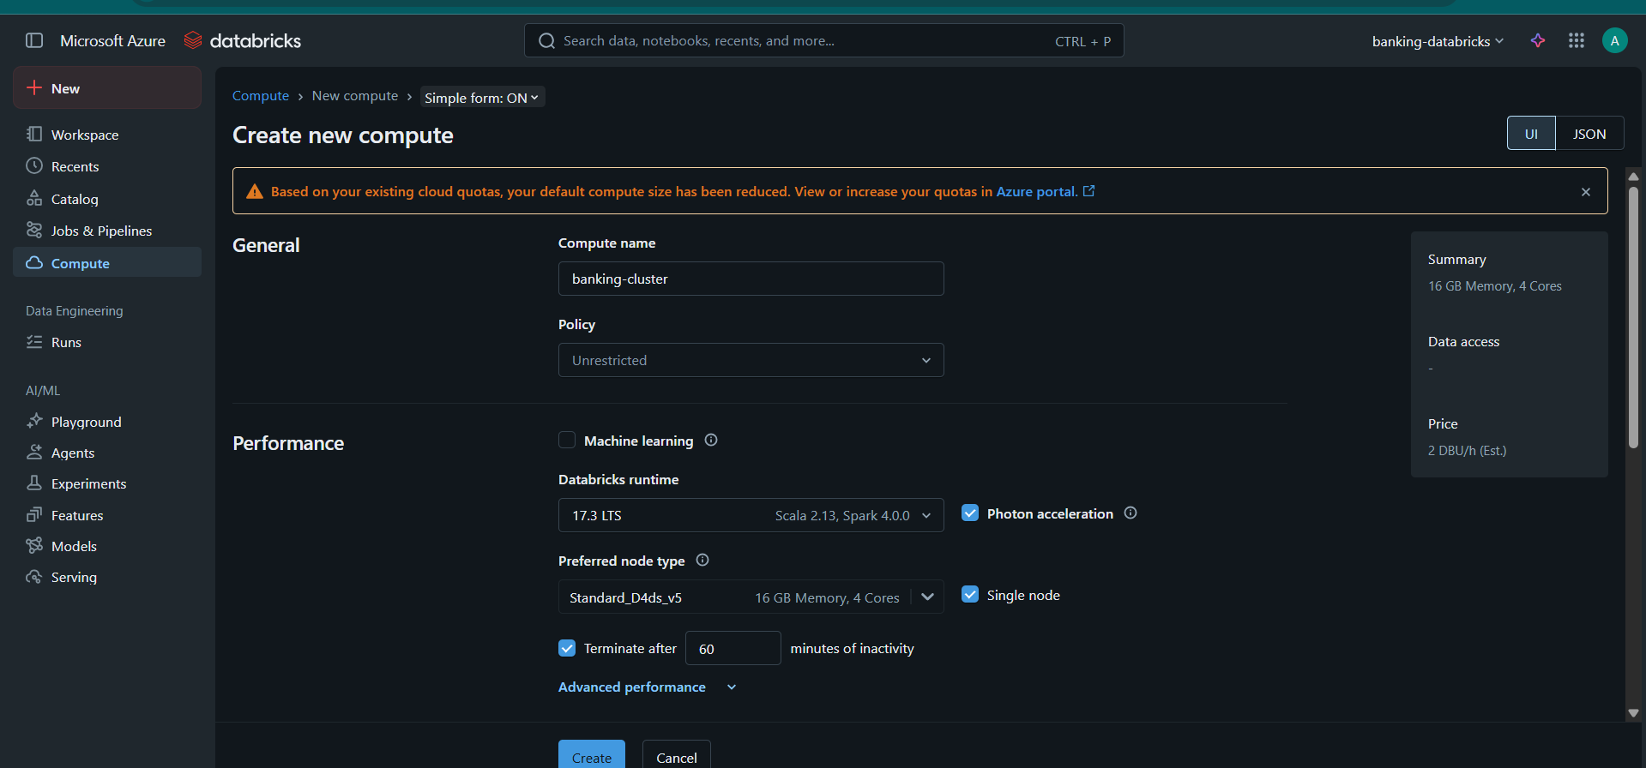
Step 7: Create Notebooks 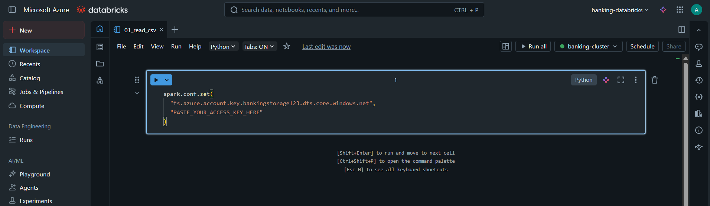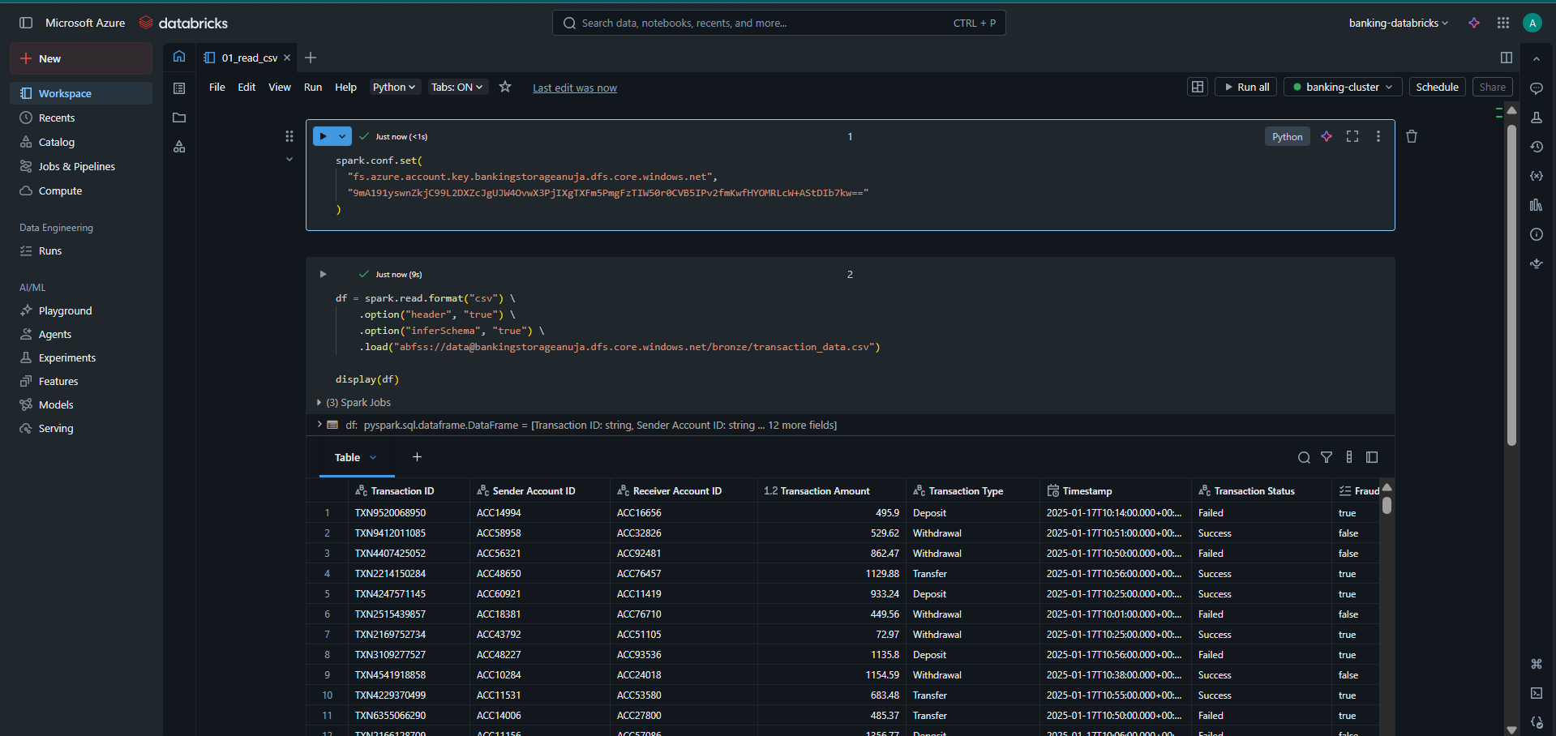
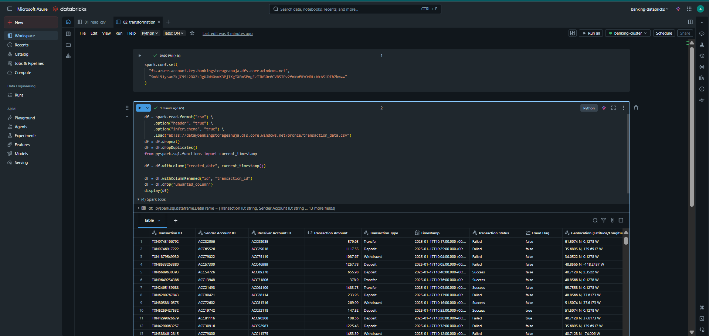

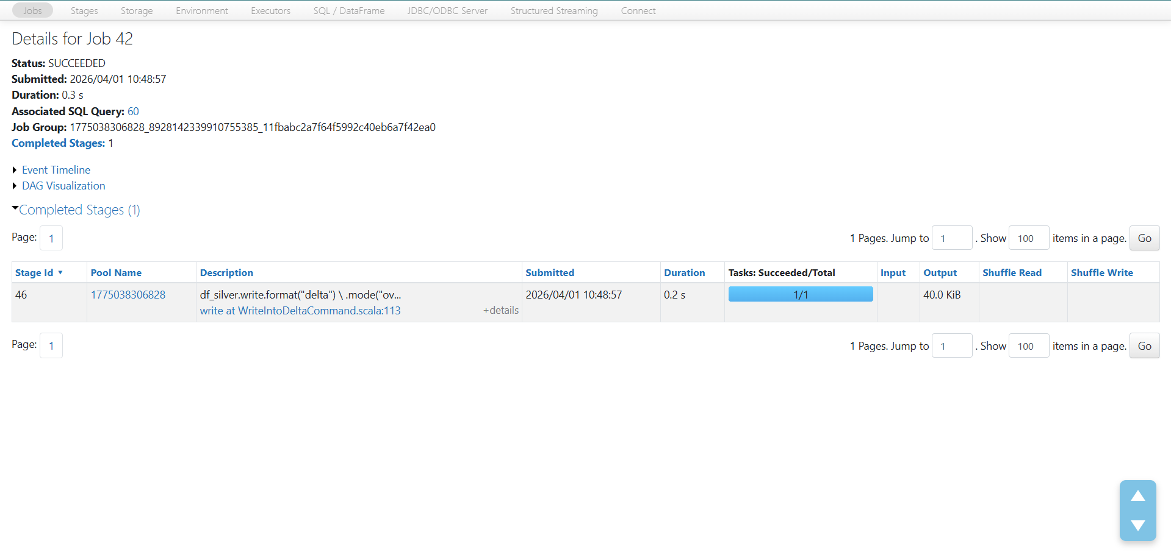
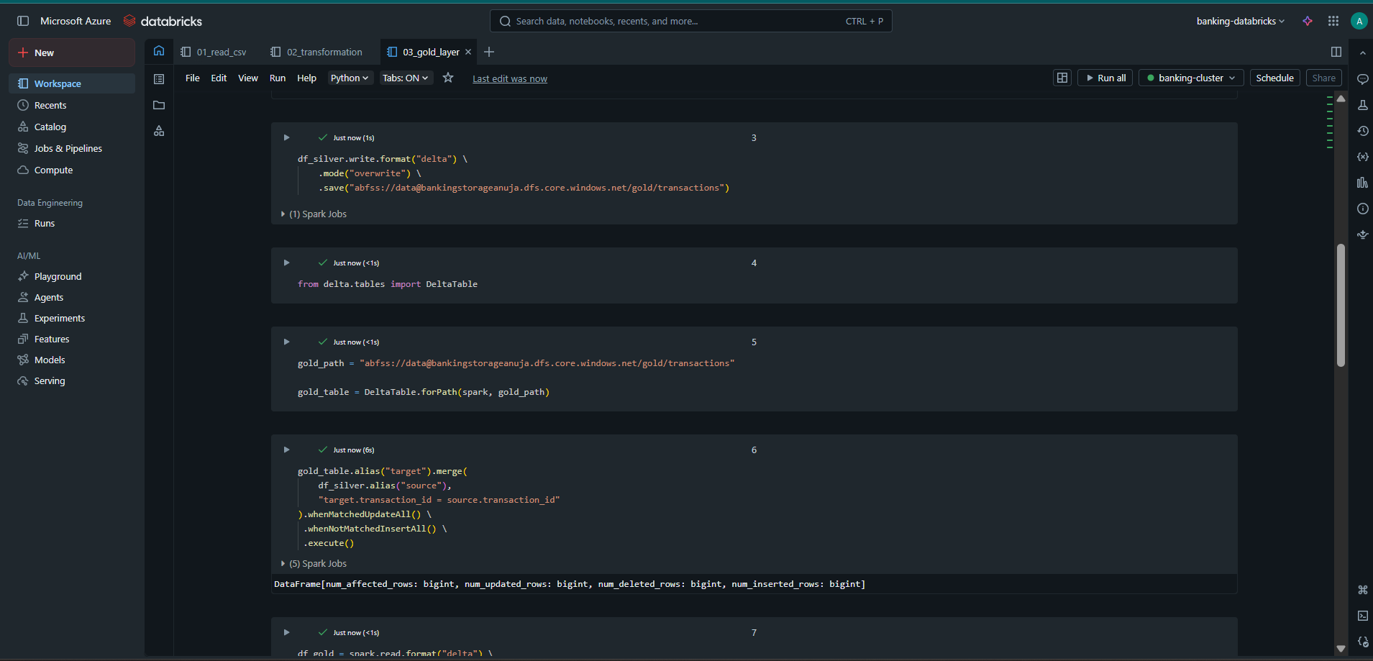
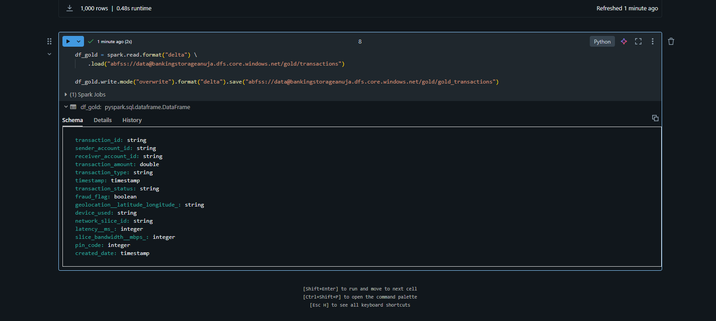

Step 8: Power BI report
